**EE222: Microprocessors Systems**

**Assignment # 01, 02 ,03**

***4-Bit Microprocessor***

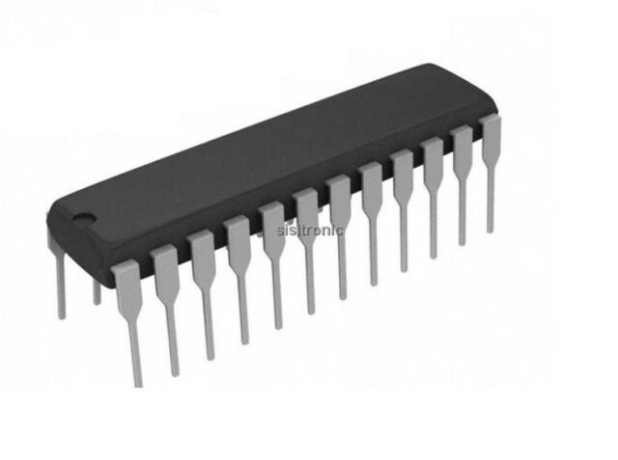

**Members:**

|  |  |
| --- | --- |
| **Names** | **Registration no.** |
| M. Talha Kamran | 392549 |
| Humayun Kamal | 366008 |
| Ramla Akhtar | 367796 |
| Umair Naeem | 332078 |
| Zehra Ali | 368493 |

**Introduction:**

A central processing unit (CPU) that processes data in 4-bit chunks is known as a 4-bit microprocessor. In the 1970s and 1980s, it was a popular option for early microcomputers. An integrated circuit called a microprocessor has all the features of a computer's central processing unit. It has the ability to take input, run calculations, and output the results. The 4-bit microprocessor can process data with a maximum length of four binary digits.

A 4-bit microprocessor can only handle simple applications due to its constrained data processing capabilities; it cannot handle complicated programs. It is nevertheless capable of carrying out simple mathematical and logical operations like addition, subtraction, multiplication, and division.

**Blocks and Components:**

4-Bit microprocessor consists of blocks or parts made up of basic components. Architecture of a 4 bit microprocessor is built upon the following parts/blocks:

* Program Counter
* 2 to 1 Multiplexer
* 16x8 RAM
* Instruction register
* Accumulator
* Adder/subtractor
* B register
* Output register
* Instruction decoder
* Ring counter
* Control matrix
* Memory address register
* Bus

Components used to make these parts are as follows:

* AND, OR, NOT, NAND, XOR gates
* Quad three state open switch
* JK flip flops
* 1k resistors
* LEDs
* Clock
* Chips:
* 74LS173
* 74LS83
* 74189
* 74LS157

**Design and Working of 4-Bit microprocessor:**

A 4-bit microprocessor is a small computer on a single chip that performs arithmetic, logic, and control operations on binary data.

The basic working of a 4-bit microprocessor is as follows:

* Using the program counter PC and memory address register MAR, the microprocessor takes an instruction from memory.
* The Instruction Decoder decodes the instruction after it has been stored in the instruction register IR.
* Control signals are produced for the Control Matrix by the Instruction Decoder.
* The Control Matrix produces control signals so that the microprocessor's parts can carry out the instruction.
* Data stored in the accumulator (ACC) and B register is subjected to arithmetic and logic operations by the ALU.
* The output register stores the operation's results.
* To identify the following instruction that will be executed, the PC is incremented.
* The cycle is repeated by the microprocessor in order to carry out the following program instruction.

The 4-Bit microprocessor we designed can implement following instructions:

**LDA** is mnemonic for instruction “*load the accumulator*”. It loads the hexadecimal value in accumulator.

**ADD** ismnemonic for instruction “add the contents of memory location to accumulator contents”.

**SUB** is mnemonic for instruction “subtract the contents of memory location from accumulator contents”.

**OUT** is mnemonic for instruction “store accumulator contents to output port”.

**HLT** is mnemonic for instruction “halt”. This instruction tells the program to stop the program.

Following are the Opcode used for the above mentioned instructions:

|  |  |
| --- | --- |
| Instructions | Opcode |
| LDA | 0000 |
| ADD | 0001 |
| SUB | 0010 |
| OUT | 0011 |
| HLT | 1111 |

Instructions are fetched by the microprocessor in form of Opcode as it understands machine language only.

**Simulation file link:**

**Conclusion:**

We designed a 4 bit microprocessor that can implement a program of at least 5 instructions i.e. LDA, ADD, SUB, OUT, and HLT.